Příloha k nařízení č. 7/2024 statutárního města Jihlavy:
„Vymezené oblasti města Jihlavy, ve kterých lze místní komunikace nebo jejich určené úseky užít za cenu sjednanou v souladu s cenovými předpisy k stání silničního motorového vozidla ve městě Jihlavě na dobu časově omezenou, nejvýše však na dobu 24 hodin, nebo k stání silničního motorového vozidla provozovaného právnickou nebo fyzickou osobou za účelem podnikání podle jiného právního předpisu, která má sídlo nebo provozovnu ve vymezené oblasti města Jihlavy, nebo k stání silničního motorového vozidla fyzické osoby, která má místo trvalého pobytu nebo je vlastníkem nemovitosti ve vymezené oblasti města Jihlavy, nebo k stání silničního motorového vozidla držitele průkazu ZTP/P, evidovaného v databázi parkovacích oprávnění města, nebo k stání silničního motorového vozidla provozovaného institucí, která má sídlo nebo pobočku ve vymezené oblasti města, nebo k stání silničního motorového vozidla provozovaného poskytovatelem sociálních služeb či zdravotní péče, evidovaného v databázi parkovacích oprávnění, nebo k stání silničního motorového vozidla provozovaného prostřednictvím carsharingu,."
Pokud je v tabulce uvedeno u čísla orientačního písmeno E, jedná se o číslo evidenční.

Vymezená oblast 01 centrum
Ulice | Čísla orientační
Benešova | 1, 2, 3, 4, 5, 6, 7, 8, 9, 10, 11, 13, 14, 15, 16, 17, 18, 19, 20, 21, 22, 23, 24, 26, 28, 29, 30, 31, 32, 34, 36, 46
Brněnská | 1, 3, 4, 5, 6, 8, 10, 11, 12, 13, 14, 15, 16, 17, 18, 19, 20, 22, 23, 24, 25, 26, 28, 29, 30, 31, 15a, 15b, 24a
Březinovy sady | 25, 31
Čajkovského | 2, 4, 5, 6, 7, 8, 9, 10, 12, 14, 15, 16, 17, 18, 19, 20, 21, 23, 25, 26, 27, 28, 29, 30, 31, 32, 33, 34, 35, 37, 38, 39, 40, 41, 43, 44, 46, 48, 3647E, 3648E
Divadelní | 4, 8, 12, 15, 17, 19, 21
Dominikánská | 4, 7
Dvořákova | 4, 6, 10
Farní | 1, 2, 4, 5
Havířská | 1, 2, 3, 4, 5, 6, 7, 8, 9, 10, 11, 12, 13, 14, 15, 16, 17, 18, 19, 20, 21, 22, 23, 24, 25, 26, 29, 31, 33, 35
Hluboká | 1, 3, 7, 8, 9, 11, 16, 18, 20
Husova | 1, 2, 3, 4, 5, 6, 7, 8, 9, 10, 11, 12, 13, 14, 15, 16, 17, 19, 20, 21, 22, 23, 24, 25, 26, 27, 29, 31, 33, 34, 36, 37, 38, 39, 40, 41, 42, 44, 45, 46, 50, 52, 3200E, 3201E, 3202E, 3205E, 3206E, 3207E
Jakubské náměstí | 1, 2, 4, 7, 8, 10
Jana Masaryka | 22
Joštova | 2, 3, 4, 5, 6, 7, 8, 9, 10, 11, 12, 13, 14, 15, 17, 19, 21, 23, 25, 27, 29, 19a, 8a
Komenského | 1, 3, 4, 5, 6, 7, 8, 9, 10, 11, 12, 14, 17, 18, 19, 20, 21, 22, 23, 24, 25, 27, 29, 30, 31, 25a
Kosmákova | 1, 2, 3, 4, 5, 7, 9, 10, 13, 15, 17, 19, 20, 21, 22, 24, 25, 27, 28, 29, 30, 31, 32, 33, 35, 37, 39, 41, 43, 45
Křivá | 1, 3, 5
Křížová | 1, 2, 3, 4, 5, 6, 7, 8, 9, 10, 11, 12, 15, 17, 18, 19, 21, 23, 25, 27, 33, 2a, 4a
Lazebnická | 1, 3, 5, 7, 8, 10, 11, 12, 13, 14, 15, 17, 18, 19, 20, 22, 24
Masarykovo náměstí | 1, 2, 3, 4, 5, 6, 7, 8, 9, 10, 13, 14, 16, 17, 18, 19, 21, 22, 23, 24, 25, 26, 29, 30, 32, 33, 34, 35, 36, 37, 39, 40, 41, 42, 43, 44, 45, 47, 48, 49, 50, 51, 52, 53, 54, 55, 57, 58, 59, 60, 64, 65, 66, 67, 68
Matky Boží | 1, 2, 3, 5, 6, 7, 8, 9, 10, 11, 12, 14, 15, 16, 17, 18, 20, 22, 23, 24, 25, 26, 27, 28, 30, 31, 33, 34, 35, 36, 37, 41, 16a, 3703E
Minoritské náměstí | 1, 3, 7, 9, 11, 1a
Mrštíkova | 1, 4, 6, 8, 10, 11, 12, 13, 14, 15, 16, 17, 18, 19, 22, 24, 26, 28, 30
Palackého | 1, 3, 5, 7, 9, 10, 11, 12, 13, 14, 15, 17, 18, 20, 21, 23, 24, 25, 26, 27, 28, 29, 30, 31, 32, 33, 35, 38, 40, 41, 42, 43, 44, 45, 46, 47, 49, 51, 53
Slepá | 1, 4
Smetanova | 2, 3, 4, 6, 8, 10, 11
Škrétova | 1, 2, 3, 4, 5, 2a
U Brány | 4
U Kasáren | 2, 3, 2a, 2b
U Mincovny | 2, 3, 4, 5, 6, 7, 8, 9
Úzká | 1, 3
Věžní | 1, 4, 6, 8, 10, 16, 26, 28, 30, 32
Znojemská | 1, 2, 3, 4, 5, 6, 7, 8, 10, 11, 13, 14, 16, 18, 6a
Židovská | 1, 2, 3, 21, 22, 24, 25, 26, 27, 28, 29, 30, 31, 33, 22a, 23a, 23b
Jihlava | 4446E, 4668E, 4673E, 4883E, 4906E

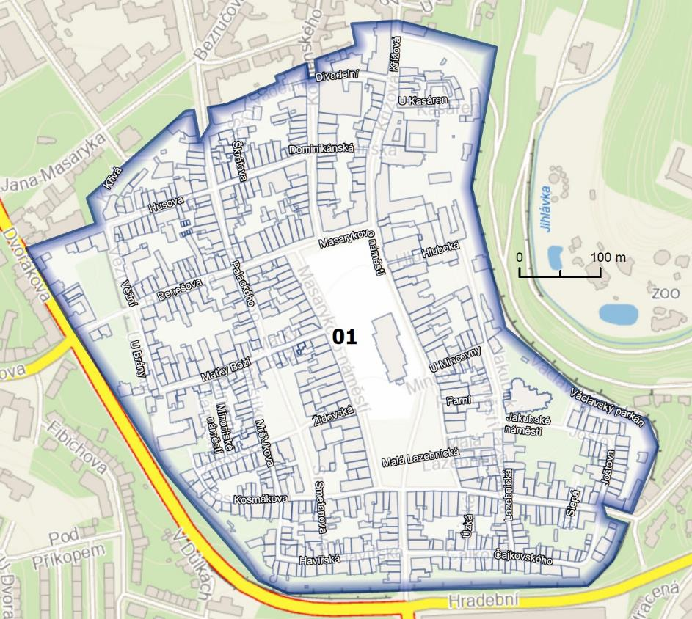

Vymezená oblast 02 Tyršova
Dvořákova | 12
Fritzova | 19, 21, 25, 21a
Husova | 54
Jana Masaryka | 1, 2, 3, 4, 6, 8, 10, 12, 14, 16, 18, 20, 3189E, 3190E
Jiráskova | 2, 8, 10, 12, 3254E, 3255E, 3256E, 3257E, 3258E, 3259E
Tolstého | 9, 11, 13, 14, 15, 16, 21
Tyršova | 2, 4, 6, 8, 10, 12, 18
třída Legionářů | 3, 5, 7, 9, 11, 9a, 9b
Jihlava | 3414E, 5067E

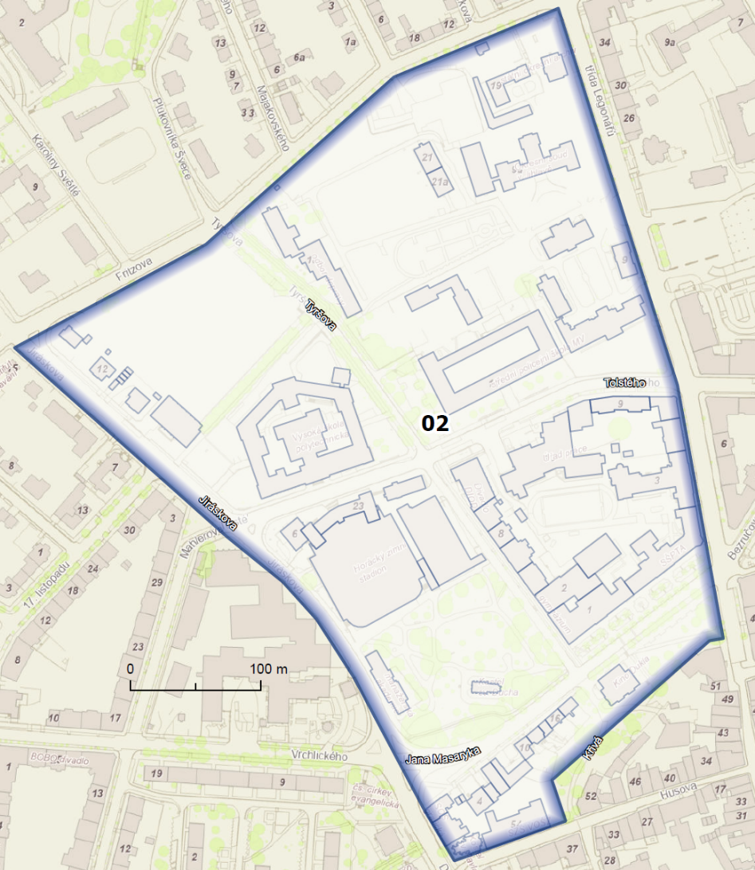
Vymezená oblast 03 Havlíčkova jih

Bezručova | 2, 3, 4, 5, 7, 8, 10
Chlumova | 1, 2, 3, 4, 6, 7, 8, 9, 10, 11, 12, 14, 16, 1a, 1b, 9a
Fritzova | 3, 9, 11, 13, 15
Havlíčkova | 11, 12, 13, 16, 18, 20, 22, 24, 26, 27, 28, 29, 30, 31, 32, 33, 34, 35, 16a, 16b, 26a, 27a, 28a, 28b, 34a, 34b
Jana Masaryka | 5, 24, 26, 28, 30, 32, 34, 36
Komenského | 32, 33, 34, 36, 38, 39, 40, 41, 43, 32a, 32b, 36a, 38a
Křížová | 20, 35
Na Stoupách | 2, 3, 6, 8, 10, 12, 14, 16, 18, 20, 22, 24, 12a, 22a
Palackého | 48, 50, 3208E
Srázná | 1, 2, 4, 5, 6, 7, 8, 9, 10, 11, 12, 13, 14, 16, 17, 18, 11a, 13a, 16a, 19a
Tolstého | 2, 3, 10
náměstí Svobody | 1, 3, 4, 9, 10, 11
třída Legionářů | 2, 4, 6, 8, 10, 24, 26, 28, 30, 32, 34, 36
Úlehlova | 1, 2, 3, 4, 5, 6, 8, 9, 10, 12, 3176E, 3177E, 3178E
Jihlava | 4918E

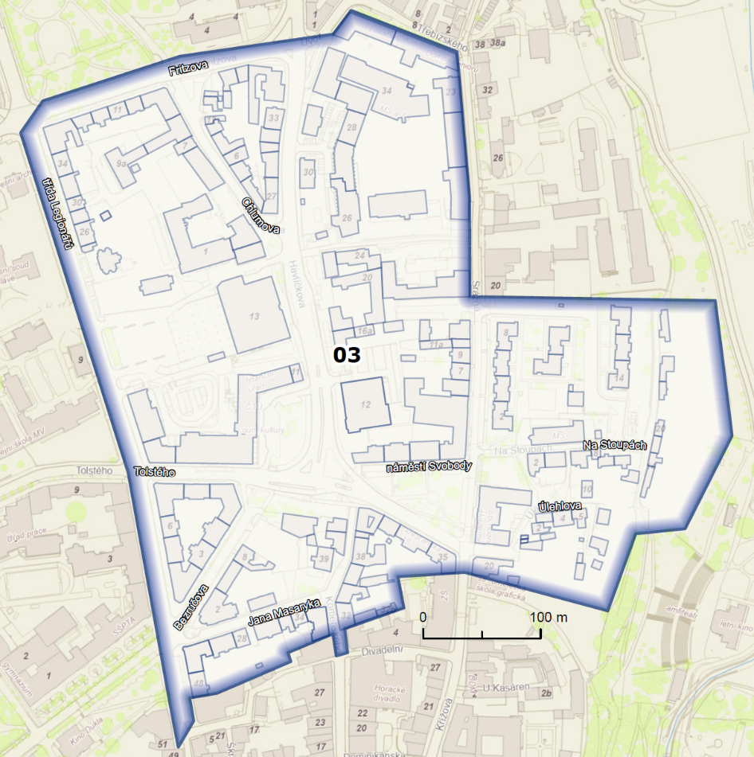
Vymezená oblast 04 U Městského nádraží
Boženy Němcové | 2, 3, 4
Chlumova | 35
Fritzova | 2, 4, 12, 14, 16, 18, 20, 22, 24, 26, 28, 32, 34
Jiráskova | 18, 20, 22, 24, 26, 28, 30, 3262E, 3263E, 3264E, 3265E, 3266E, 3267E, 3268E, 3269E
Karoliny Světlé | 2, 7, 9, 11, 13, 15
Majakovského | 3, 4, 5, 6, 7, 8, 9, 10, 11, 12, 13, 14, 15, 16, 17, 18, 20, 22, 24, 6a, 3330E, 3331E, 3332E, 3333E
Nerudova | 1, 2, 3, 4, 5, 6, 7, 8, 9, 10, 11, 12, 13, 14, 16, 18, 20, 22, 24, 26, 28, 1a, 3339E
Plukovníka Švece | 1, 2, 4, 6, 8
U Městského nádraží | 1, 2, 4, 6, 21, 23, 25, 27, 29, 31, 4a
třída Legionářů | 15, 17, 15a
Úprkova | 3, 5, 6, 7, 9, 11, 13, 15, 17, 19, 21, 23, 25
Jihlava | 1475E, 1476E, 1477E, 1478E, 1479E, 1480E, 1481E, 1482E, 1483E, 1484E, 1485E, 1486E, 1487E, 1488E, 1489E, 1490E, 1491E, 1492E, 1493E, 1494E, 1495E, 1496E, 1497E, 1498E, 1499E, 1500E, 1501E, 1502E, 1503E, 1504E, 1505E, 1506E, 1511E, 1512E, 1513E, 1514E, 1515E, 1516E, 1517E, 1518E, 1519E, 1520E, 3296E, 3297E, 3298E, 3299E, 3300E, 3301E, 3302E, 3303E, 3304E, 4056E, 4786E, 4880E, 5049E

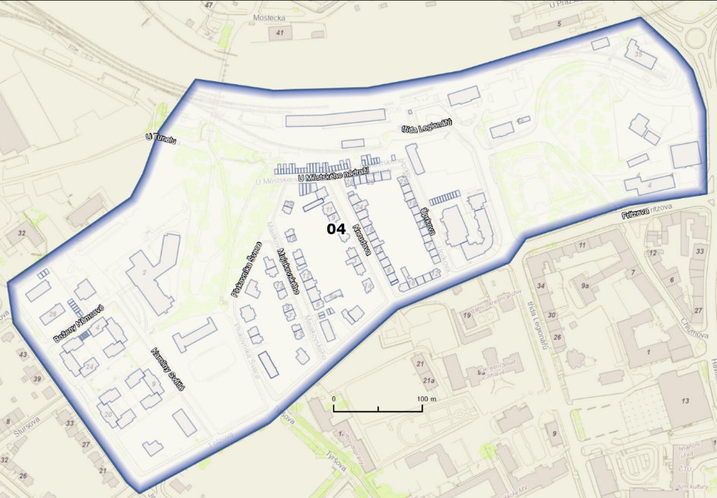

Vymezená oblast 05 Úvoz

Gorkého | 3, 5, 7, 9, 11, 13
Havlíčkova | 36, 38, 40, 44, 46, 58, 60, 62, 64, 60a, 62a
Mlýnská | 2, 4, 6, 8, 10, 12, 14, 16, 18, 20, 3467E, 3469E
Na Stoupách | 9, 28, 30, 32, 3186E, 3187E, 3188E
Rokycanova | 3, 4, 5, 6, 7, 8, 9, 10, 11, 2713E, 2714E, 2853E, 2854E, 2855E, 2856E, 2857E, 2858E, 2859E, 2860E, 2861E, 2862E, 2863E, 2864E
Srázná | 19, 20, 21, 22, 23, 24, 25, 26, 27, 29, 30, 31, 32, 33, 34, 36, 38, 40, 42, 44, 46, 48, 20c, 38a
Třebízského | 2, 4, 6, 8, 10, 12, 14, 16, 18, 20, 22, 6a
Úvoz | 1, 3, 5, 6, 7, 8, 10, 11, 12, 13, 15, 17, 18, 19, 21, 23, 24, 25, 26, 27, 28, 34, 36
Jihlava | 2121E, 2122E, 2123E, 2124E, 2125E, 2126E, 2127E, 2128E, 2129E, 2130E, 2131E, 4037E, 4082E, 4736E, 4737E, 4738E, 4740E, 5021E, 5370E

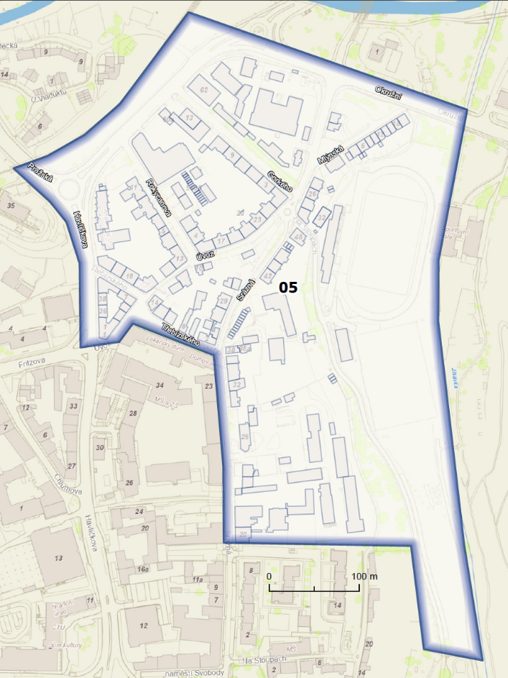
Vymezená oblast 32 Křižíkova
Brněnská | 33, 35, 37, 39, 43, 46, 48, 50, 52
Březinovy sady | 1, 3, 4, 5, 7, 9, 11, 15, 17, 21, 21a
Křižíkova | 10, 13, 10a
Jihlava | 2482E, 2483E, 2484E, 2485E, 2486E, 2487E, 2488E, 2489E, 2490E, 2491E, 2492E

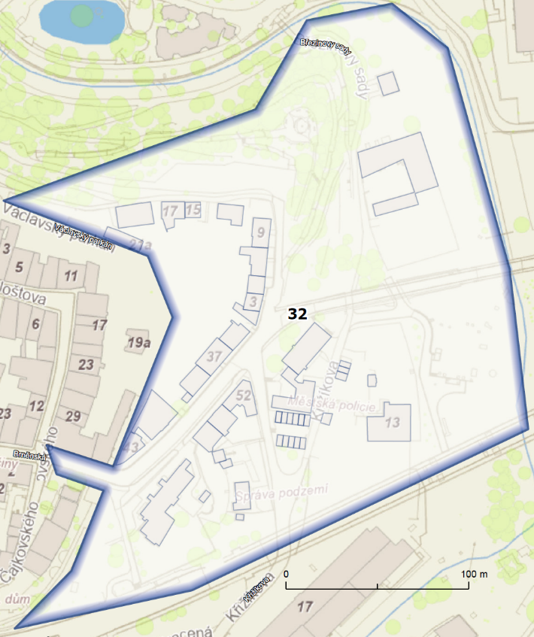

Vymezená oblast 51 Fibichova
Fibichova | 1, 2, 3, 4, 5, 6, 7, 9, 11, 13, 15, 17, 18, 19, 20, 21, 22, 23, 24, 25, 26, 27, 28, 29, 31, 33, 35, 37, 39, 41, 43, 45, 53, 55, 57, 59, 61, 63, 65, 67, 69, 71, 73, 75, 77, 81, 83, 85, 87, 89, 2825E, 2826E, 2827E, 2828E, 3448E, 3449E, 3451E, 3452E, 3453E, 3454E, 4447E
Na Sádkách | 1, 2, 3, 4, 6, 1a, 3457E, 3458E, 5052E
Pod Příkopem | 4, 6
Seifertova | 4, 5, 6, 7, 8, 9, 11, 13, 15, 17, 4a
Svatopluka Čecha | 2, 3, 4, 5, 6, 7, 8, 9, 10, 11, 12, 13, 14, 15, 16, 3461E, 3727E, 3728E
Telečská | 7, 9, 11, 13, 15, 24, 26, 28, 30, 32, 34, 36, 38, 4078E
U Dvora | 3, 4, 5, 7, 9, 11, 17, 19, 21, 23, 2897E, 2898E
V Důlkách | 2, 16, 18, 20, 22, 24, 3455E, 3456E
Wolkerova | 4, 6, 8, 10, 12, 14, 18, 20, 22, 24, 26, 28, 3707E, 3708E, 3709E, 3710E, 3711E
Zahradní | 2, 4, 5, 6, 7, 8, 10, 11, 12, 13, 14, 15, 16, 17, 18, 19, 20, 21, 22, 24, 26, 28, 30, 3445E
Žižkova | 3, 5, 9, 13, 15, 17, 27, 29, 31, 33, 35, 37, 39, 41, 43
Jihlava | 1025E, 1026E, 1027E, 1028E, 1029E, 1030E, 1048E, 1049E, 1050E, 2735E, 2736E, 2737E, 2738E, 2739E, 2740E, 2741E, 2742E, 2743E, 2744E, 2745E, 2746E, 2747E, 2748E, 2749E, 2750E, 2751E, 2752E, 2753E, 2754E, 2755E, 2756E, 2757E, 2758E, 2759E, 2760E, 2761E, 2762E, 2763E, 2764E, 2765E, 2766E, 2767E, 2768E, 2769E, 2805E, 2806E, 2807E, 2808E, 2809E, 2810E, 3720E, 3721E, 3722E, 3723E, 3724E, 4035E, 4058E, 4059E, 4060E, 4061E, 4405E, 4406E, 4407E, 4408E, 4409E, 4410E, 4411E, 4412E, 4413E, 4414E, 4415E, 4416E, 4417E, 4418E, 4419E, 4420E, 4421E, 4422E, 4423E, 4424E, 4425E, 4426E, 4427E, 4428E, 4429E, 4430E, 4431E, 4433E, 4435E, 4436E, 4437E, 4438E, 4439E, 4440E, 4441E, 4442E, 4443E, 4444E, 4445E, 4959E, 4960E, 4961E, 4962E, 4963E, 4964E, 4965E, 4966E, 4967E, 5242E, 5243E, 874E, 875E, 876E, 877E, 878E, 879E

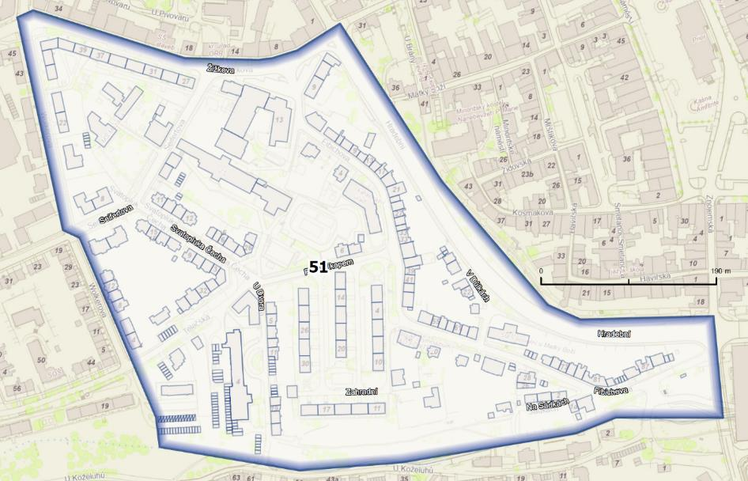

Vymezená oblast 52 U Pivovaru
Ulice | Čísla orientační
17. listopadu | 8, 10, 12, 14, 16, 18, 20, 22, 24, 26, 28, 30, 32, 34, 3224E, 3225E
Dvořákova | 1, 3, 5, 7, 9, 11, 13
Jiráskova | 3
Mahlerova | 1, 3, 4, 5, 6, 7, 8, 9, 10, 11, 12, 13, 14, 16, 17, 19, 21, 23, 25, 27, 29, 31, 33, 5020E
Malátova | 3, 4, 5, 6, 7, 8
Štefánikovo náměstí | 1, 2, 3, 4, 5, 6, 9, 10, 25
U Pivovaru | 1, 2, 3, 4, 5, 6, 7, 8, 9, 10, 11, 12, 13, 14, 3216E
Vrchlického | 1, 2, 5, 6, 7, 8, 9, 10, 11, 12, 13, 15, 17, 19, 21, 23, 25, 27
Žižkova | 4, 6, 8, 10, 12, 14, 16, 18, 20, 32, 34, 38, 42, 44, 46, 50, 52
Jihlava | 2969E, 2970E, 2971E, 2972E, 2973E, 2974E, 3885E, 3886E, 3887E, 3888E, 4922E, 4987E

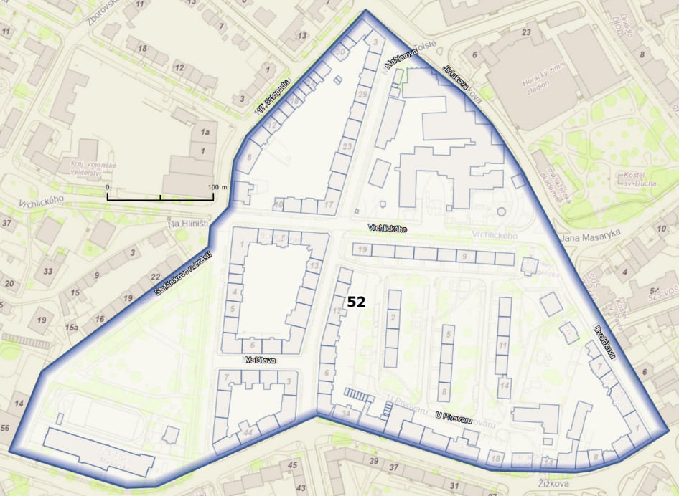

Vymezená oblast 53 Ke Skalce
Bratří Čapků | 1, 3, 4, 5, 6, 8, 10, 12, 18, 22
Ke Skalce | 2, 3, 4, 5, 6, 7, 8, 9, 10, 11, 12, 13, 14, 15, 16, 17, 18, 19, 20, 21, 22, 23, 24, 25, 27, 29, 30, 31, 32, 33, 35, 37, 47, 3464E, 3466E
Seifertova | 10, 12, 14, 16, 18, 19, 20, 21, 22, 23, 24, 25, 26, 27, 29, 31, 33, 35, 37, 39, 43, 45, 47, 49, 51, 53, 55, 57, 59, 63, 65, 67, 69, 71, 73, 75
Telečská | 17, 19, 21, 23, 25, 27, 29, 31, 33, 35, 37, 39, 41, 42, 43, 44, 45, 46, 47, 48, 49, 50, 51, 52, 54, 56, 60, 62, 64, 66, 68, 70, 72, 74, 76, 78, 80, 82, 86, 88, 90, 92, 94, 96, 98, 100
U Hřbitova | 1
U Koželuhů | 77, 79
Wolkerova | 3, 5, 7, 9, 11, 13, 15, 17, 19, 21, 23, 25, 27, 29, 31, 33, 35, 37, 39, 41, 43, 3712E, 3713E, 3714E, 3715E, 5324E
Žižkova | 45, 47, 49, 51, 53, 57, 83, 85, 87
Jihlava | 1032E, 1033E, 1034E, 1035E, 1036E, 3991E, 4359E, 4360E, 4454E, 4756E, 4757E, 4758E, 4759E, 4760E, 4761E, 4762E

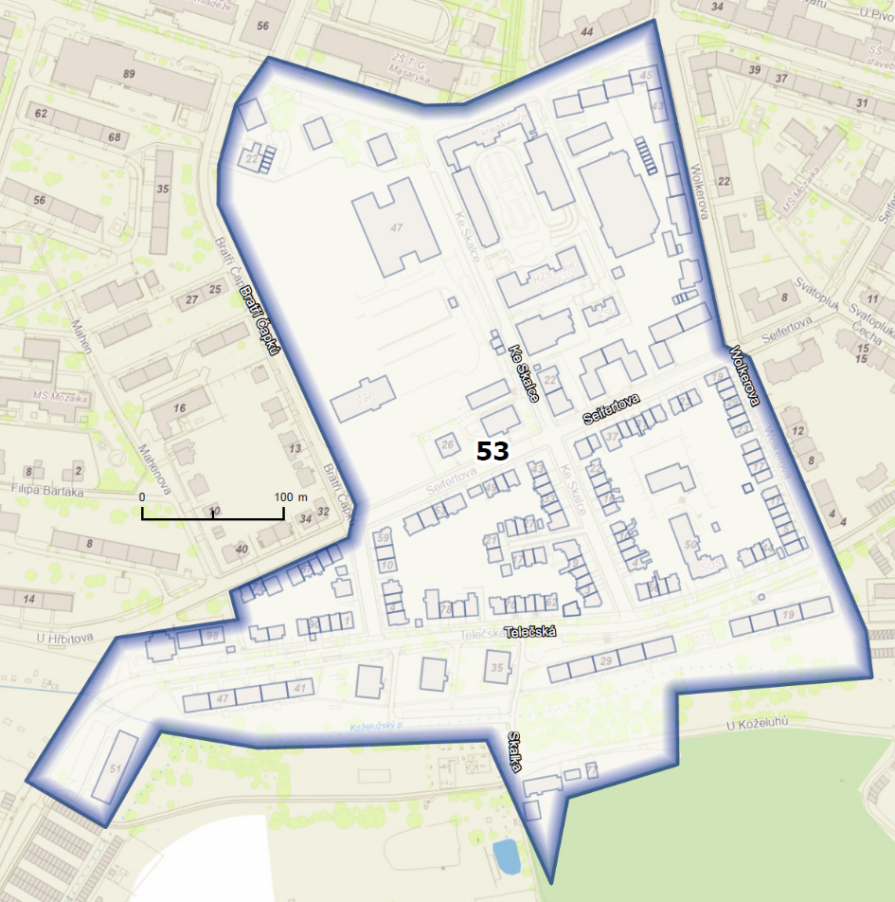

Vymezená oblast 54 U Hřbitova
Bratří Čapků | 9, 11, 13, 15, 17, 19, 21, 23, 25, 27, 31, 33, 35, 37, 17a, 971E
Filipa Bartáka | 2, 4, 6, 8, 10, 12
Mahenova | 3, 10, 12, 14, 16, 22, 24, 26, 28, 30, 14a
Seifertova | 32, 34, 36, 38, 40, 42
Sukova | 1, 3, 4, 5, 6, 7, 8, 9, 10, 11, 12, 13, 14, 15, 18, 20, 22, 24, 26, 28, 30, 32
U Cvičiště | 2, 4, 6, 12, 14, 16, 18, 20, 22, 1188E, 4770E
U Hřbitova | 2, 4, 6, 8, 10, 12, 14, 16, 18, 20, 22, 24, 26, 28, 30, 32, 34, 36, 38, 40, 42, 44, 46, 48, 50, 52, 54, 56, 58, 60, 62, 64, 66, 68, 10a
Štefánikovo náměstí | 14
Žižkova | 56, 58, 89, 93
Jihlava | 1037E, 1038E, 1040E, 2873E, 2874E, 2875E, 2876E, 2877E, 2878E, 2879E, 2880E, 2881E, 2882E, 2883E, 2884E, 2885E, 2886E, 2887E, 2888E, 2889E, 2890E, 2891E, 2892E, 2893E, 2894E, 2895E, 2896E, 2956E, 2957E, 2958E, 2959E, 2960E, 2961E, 2962E, 2963E, 2964E, 2965E, 2966E, 2967E, 2968E, 3704E, 3869E, 3870E, 4034E, 4353E, 4763E, 5697
Pístov | 347E, 348E, 349E, 350E, 351E, 352E

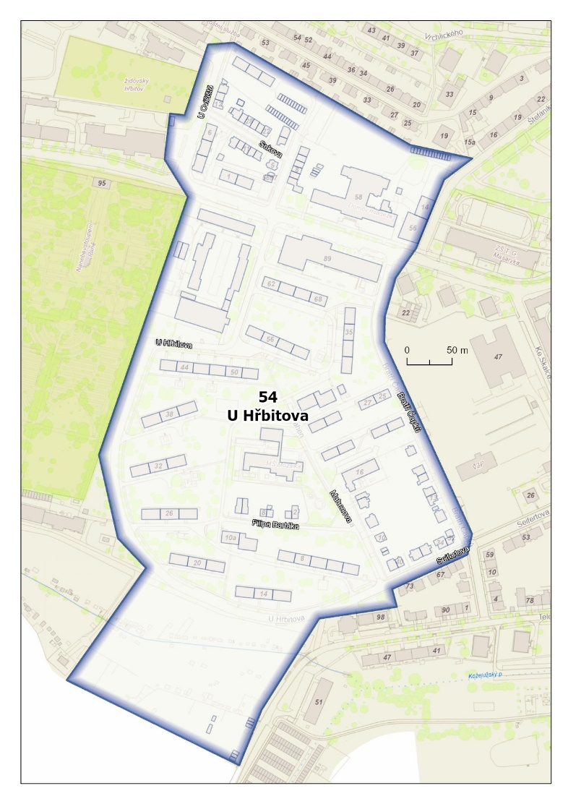
Vymezená oblast 55 Zborovská
Ulice | Čísla orientační
17. listopadu | 1, 3, 5, 7, 11, 13, 1a
Erbenova | 1, 2, 3, 4, 5, 7, 8, 9, 10, 11, 13, 15, 16, 18, 20, 22, 23, 24, 25, 26, 27, 28, 29, 30, 31, 32, 36, 38, 40, 42, 3229E, 3231E, 3232E, 4088E
Hamerníkova | 1, 3, 5, 7, 9, 11, 13, 15, 17, 19, 21, 23, 25, 27, 29, 31, 3313E, 3314E, 3315E, 3316E, 3317E, 3318E, 3319E, 3320E, 3321E, 3322E
Jiráskova | 7, 9, 11, 13, 15, 19, 21, 23, 25, 27, 29, 31, 33, 35, 39, 41, 43, 45, 3253E
Leoše Janáčka | 6, 8, 9, 10, 11, 12, 13, 14, 15, 16, 17, 18, 19, 20, 21, 22, 26, 28, 30, 32, 34, 36, 38, 40, 42, 44
Na Hliništi | 1, 3, 5, 7, 9, 11, 13, 15, 17, 18, 19, 20, 22, 23, 24, 25, 26, 27, 28, 29, 30, 31, 32, 33, 34, 35, 36, 37, 38, 39, 40, 41, 42, 43, 44, 45, 46, 47, 48, 49, 50, 51, 52, 53, 54, 55, 56, 57, 58, 3628E, 3630E, 3631E, 3633E, 3634E, 3635E, 3636E, 3637E, 3638E, 3639E, 3640E, 3643E, 3644E
Štefánikovo náměstí | 15, 16, 17, 18, 19, 20, 21, 22, 23, 24, 15a
Štursova | 2, 3, 4, 6, 8, 10, 12
Vrchlického | 14, 16, 26, 28, 29, 30, 31, 32, 33, 34, 36, 37, 38, 39, 40, 41, 42, 43, 44, 45, 47, 49, 51, 53, 55, 12a, 12b
Zborovská | 2, 3, 4, 5, 6, 7, 8, 9, 10, 11, 12, 13, 14, 20, 22, 24, 25, 26, 28, 30, 32, 34, 3310E, 3311E, 3312E
Jihlava | 3307E, 3308E, 3309E, 3958E, 3959E, 3973E, 3974E, 4091E, 4092E, 4222E, 4227E, 4350E, 4361E, 4373E, 4398E, 4739E, 4940E

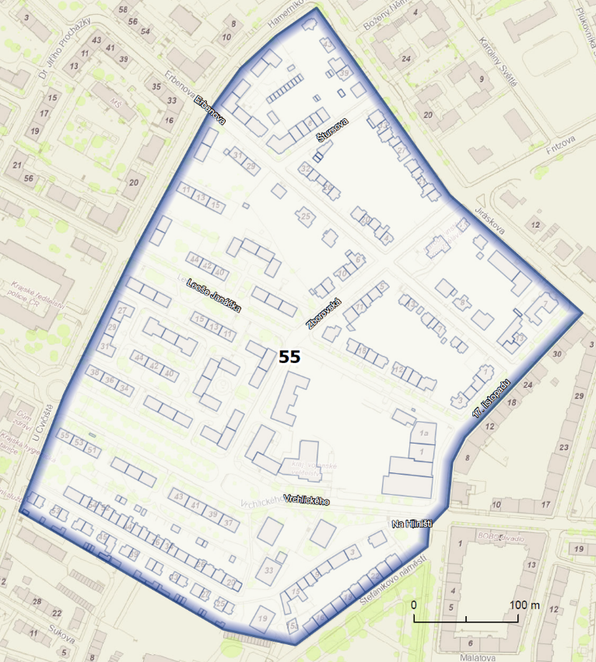

Vymezená oblast 56 Nemocnice

U Hřbitova | 21
Vrchlického | 57, 59, 61, 57a
Žižkova | 95, 98, 102, 104, 106, 108, 109, 110, 2840E, 2841E, 2842E, 2843E, 2844E, 2845E, 2846E, 2847E, 2848E, 2849E, 2850E, 2851E, 2852E
Jihlava | 1015E, 1016E, 1051E, 1052E, 1053E, 1054E, 1055E, 1056E, 1057E, 1058E, 1059E, 1060E, 1061E, 1062E, 1063E, 1064E, 1065E, 1066E, 1067E, 1068E, 1069E, 1070E, 1071E, 1072E, 1073E, 1074E, 1075E, 1076E, 1077E, 1078E, 1079E, 1080E, 1081E, 1082E, 1083E, 1084E, 1085E, 1086E, 1087E, 1088E, 1089E, 1090E, 1091E, 1092E, 1093E, 1094E, 2717E, 2718E, 2719E, 2720E, 2721E, 2722E, 2723E, 2724E, 2725E, 2726E, 2727E, 2728E, 2729E, 2730E, 2731E, 2732E, 2733E, 3004E, 3005E, 3006E, 3007E, 3008E, 3011E, 3013E, 3014E, 3015E, 3016E, 3964E, 5071E, 5113E, 5385E, 5422E, 753E, 754E, 755E, 756E, 757E, 758E, 759E, 760E, 761E, 762E, 763E, 764E, 765E, 766E, 767E, 768E, 769E, 770E, 771E, 772E, 773E, 774E, 775E, 776E, 777E, 778E, 779E, 780E, 781E, 782E, 783E, 784E, 785E, 786E, 787E, 788E, 789E, 790E, 791E, 792E, 793E, 794E, 795E, 796E, 797E, 798E, 799E, 800E, 801E, 802E, 803E, 804E, 805E, 806E, 807E, 808E, 809E, 810E, 811E, 812E, 813E, 814E, 815E, 816E, 817E, 818E, 819E, 820E, 821E, 822E, 823E, 824E, 825E, 826E, 827E, 828E, 829E, 830E, 831E, 832E, 833E, 834E, 835E, 836E, 837E, 838E, 839E, 840E, 841E, 842E, 843E, 844E, 845E, 846E, 847E, 848E, 849E, 850E, 851E, 852E, 853E, 854E, 855E, 856E, 857E, 858E, 859E, 860E, 861E, 862E, 863E, 864E, 865E, 866E, 867E, 868E, 869E, 870E, 871E, 872E, 873E
Pístov | 151E, 152E, 154E, 155E, 156E, 157E, 158E, 163E, 164E, 165E, 166E, 167E, 178E, 179E, 183E, 184E, 186E, 189E
Rantířovská | 2, 2a, 5597

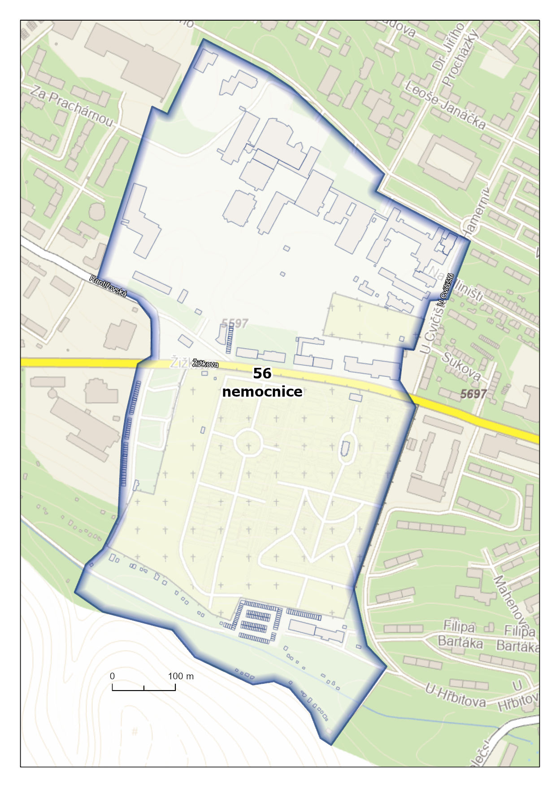

Vymezená oblast 57 Ladova

Dr. Jiřího Procházky | 7, 8, 10, 11, 12, 13, 14, 15, 16, 17, 18, 19, 20, 21
Erbenova | 33, 35, 37, 39, 41, 43, 46, 48, 50, 54, 56, 58
Evžena Rošického | 1, 2, 3, 5, 7, 9, 11
Hamerníkova | 8, 10, 12, 16, 18, 20, 22
Jiráskova | 49, 65, 67
Ladova | 1, 2, 3, 4, 5, 6, 7, 8, 9, 10, 11, 12, 13, 14, 15, 17
Leoše Janáčka | 23, 25, 27, 29, 31, 33, 50, 52, 54, 56, 58, 60
Pavlovova | 1, 3, 4, 5, 6, 7, 8, 9, 10, 12, 14, 16, 18
Vrchlického | 46, 50, 52, 54, 56, 58, 60
Zátopkova | 1, 2, 3, 4, 5, 6, 7, 8, 10, 12, 14, 16

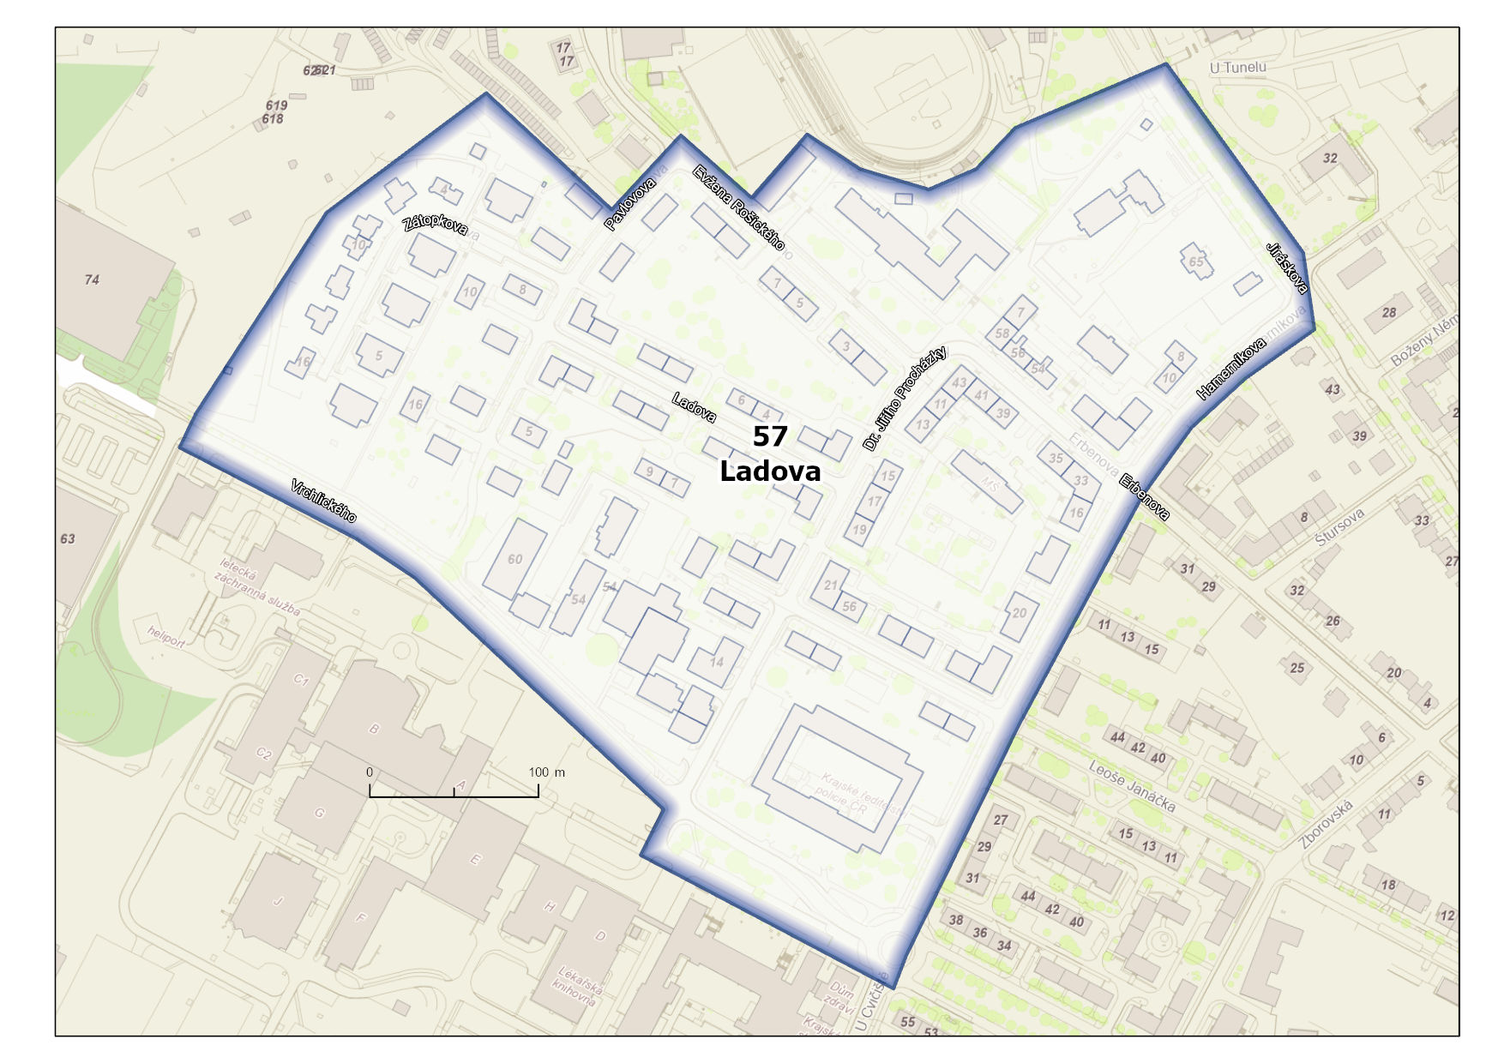

Vymezená oblast 58 Za Prachárnou
Rantířovská | 1, 4, 5, 6, 7, 9, 11, 13, 11a, 11b
Za Prachárnou | 1, 3, 5, 7, 9, 10, 11, 12, 13, 14, 15, 16, 17, 18, 19, 20, 21, 22, 23, 25, 27, 29, 31, 33, 35, 37, 39, 41, 43, 45, 47, 1a, 7a
Žižkova | 111, 118, 120, 129, 131, 133, 109a
Horní Kosov | 4563E, 4564E, 4565E, 4566E, 4567E, 4568E, 4569E, 4570E, 4571E, 4572E, 4573E, 4574E, 4575E, 4577E, 4578E, 4579E, 4580E, 4581E, 4583E, 4584E, 4585E, 4586E, 4587E, 4588E, 4589E, 4590E, 4591E, 4592E, 4593E, 4654E, 4655E, 4656E, 4657E, 4658E, 4659E, 4660E, 4661E
Jihlava | 3021E, 3022E, 3023E, 3026E, 3027E, 3029E, 3031E, 3032E, 3033E, 3035E, 3036E, 3037E, 3038E, 3039E, 3040E, 3041E, 4614E, 4618E, 4925E, 4950E, 5009E, 5016E, 5060E, 5086E, 5273E, 5349E, 5364E
Pístov | 136E, 140E, 3042E, 3045E, 3046E, 3052E, 3067E, 5312E, 5409E

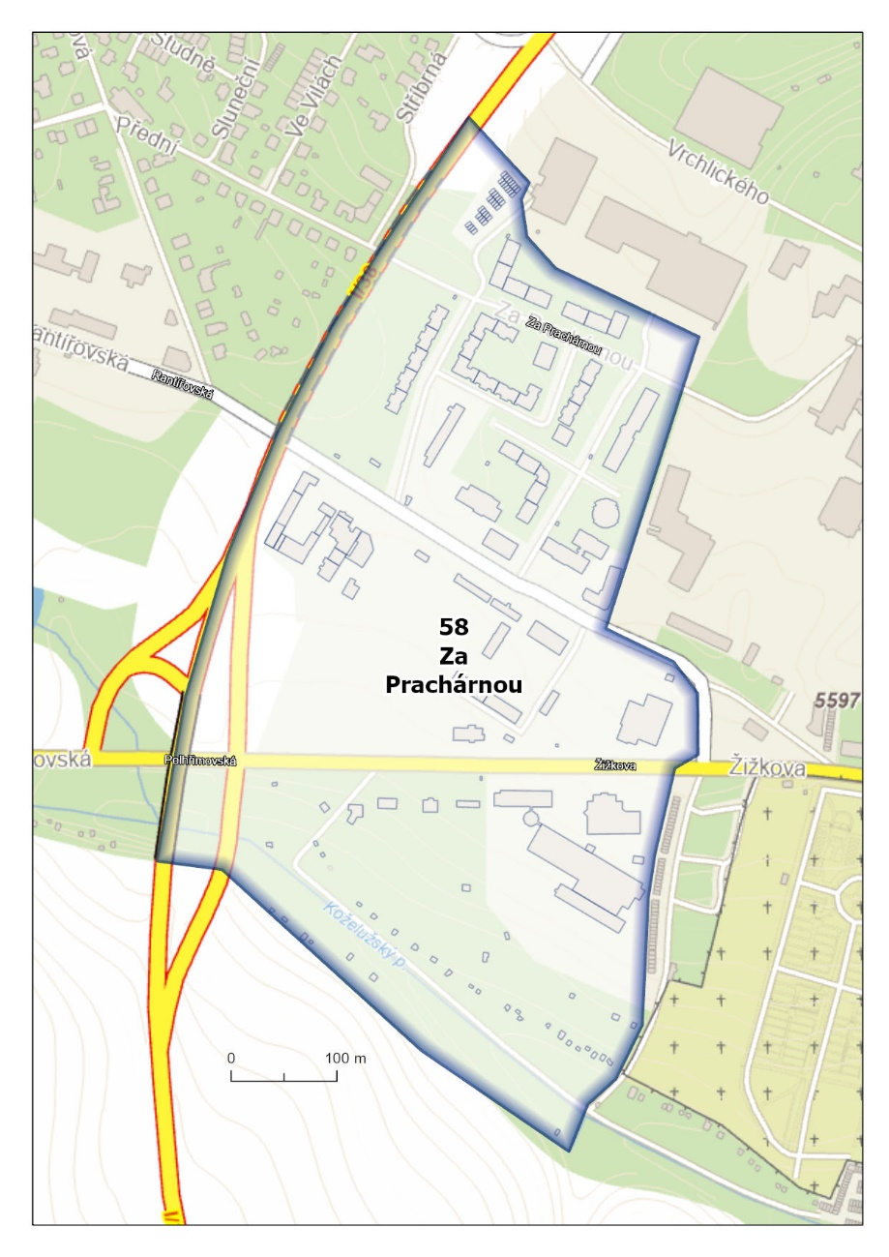

Vymezená oblast 59 Kpt. Jaroše
Evžena Rošického | 6, 12, 13, 14, 15, 17, 19, 21, 22, 23, 25, 27, 29, 31, 33, 35, 37, 39, 41, 43, 45, 47
Jiráskova | 69, 71, 73, 75, 77, 79, 81, 83, 85, 87, 89, 91, 93, 95, 97, 99, 101, 103, 105, 107, 109, 111, 113, 115, 117, 121, 123, 3270E, 3271E, 3272E, 3274E, 3275E, 3276E, 3277E, 3278E, 3279E, 3280E, 3281E, 3282E, 3283E, 3284E, 3285E, 3286E, 3287E, 3288E
Kpt. Jaroše | 1, 2, 3, 4, 5, 6, 7, 8, 9, 10, 11, 12, 13, 14, 15, 16, 17, 18, 19, 20, 21, 22, 23, 24, 25, 26, 27, 28, 29, 30, 31, 32, 33, 34, 35, 36, 37, 38, 39, 40, 41, 1a
Vrchlického | 63, 69, 74
Horní Kosov | 10E, 11E, 12E, 13E, 237E, 5379E, 5380E, 5E, 618, 619, 620, 621
Jihlava | 1095E, 1096E, 1097E, 1098E, 1099E, 1100E, 1101E, 1102E, 1103E, 1104E, 1105E, 1106E, 1107E, 1108E, 1109E, 1110E, 1111E, 1112E, 1113E, 1114E, 1115E, 1116E, 1117E, 1118E, 1119E, 1120E, 1121E, 1122E, 1123E, 1124E, 1125E, 1126E, 1127E, 1128E, 1129E, 1130E, 1131E, 1132E, 1133E, 1134E, 1135E, 1136E, 1137E, 1138E, 1139E, 1140E, 1141E, 1142E, 1143E, 1144E, 1145E, 1146E, 1147E, 1148E, 1149E, 1150E, 1151E, 1152E, 1153E, 1154E, 1155E, 1156E, 1157E, 1158E, 1159E, 1160E, 1161E, 1162E, 1163E, 1164E, 1165E, 1166E, 1167E, 1168E, 1169E, 1170E, 1171E, 1172E, 1173E, 1174E, 1175E, 1176E, 1177E, 1178E, 1179E, 1180E, 1181E, 1182E, 1183E, 1184E, 1185E, 1186E, 1187E, 1189E, 1190E, 1191E, 1192E, 1193E, 1194E, 1195E, 1196E, 1197E, 1198E, 1199E, 1200E, 1201E, 1202E, 1203E, 1204E, 1205E, 1206E, 1207E, 1208E, 1209E, 1210E, 1211E, 1212E, 1213E, 1214E, 1215E, 1216E, 1217E, 1218E, 1219E, 1220E, 1221E, 1222E, 1223E, 1224E, 1225E, 1226E, 1227E, 1228E, 1229E, 1230E, 1231E, 1232E, 1233E, 1234E, 1235E, 1236E, 1237E, 1238E, 1239E, 1240E, 1241E, 1242E, 1243E, 1244E, 1245E, 1246E, 1247E, 1248E, 1249E, 1250E, 1251E, 1252E, 1253E, 1254E, 1255E, 1256E, 1257E, 1258E, 1259E, 1260E, 1261E, 1262E, 1263E, 1264E, 1265E, 1266E, 1267E, 1268E, 1269E, 1270E, 1271E, 1272E, 1273E, 1274E, 1275E, 1276E, 1277E, 1278E, 1279E, 1280E, 1281E, 1282E, 1283E, 1284E, 1285E, 1286E, 1287E, 1288E, 1289E, 1290E, 1291E, 1292E, 1293E, 1294E, 3860E, 3868E, 4081E, 4559E, 4560E

