Příloha č.1 k obecně závazné vyhlášce č.5/2023
st.280/2, st.280/3, st.280/4, st.312/1, st.312/2, st.313, st.314, st.326, st.338, st.356, st.357, st.358, st.359, st.360, st.361, st.362, st.363, st.364, st.366, st.367, st.368, st.371, st.374, st.375, st.466, st.478, st.479, st.481, st.482, st.483, st.484, st.488, st.489, st.490, st.491, st.492, st.494, st.496, st.497, st.498, st.499, st.500, st.501, st.502, st.503, st.504, st.505, st.506, st.508, st.510 vše v k.ú. Opatovice nad Labem
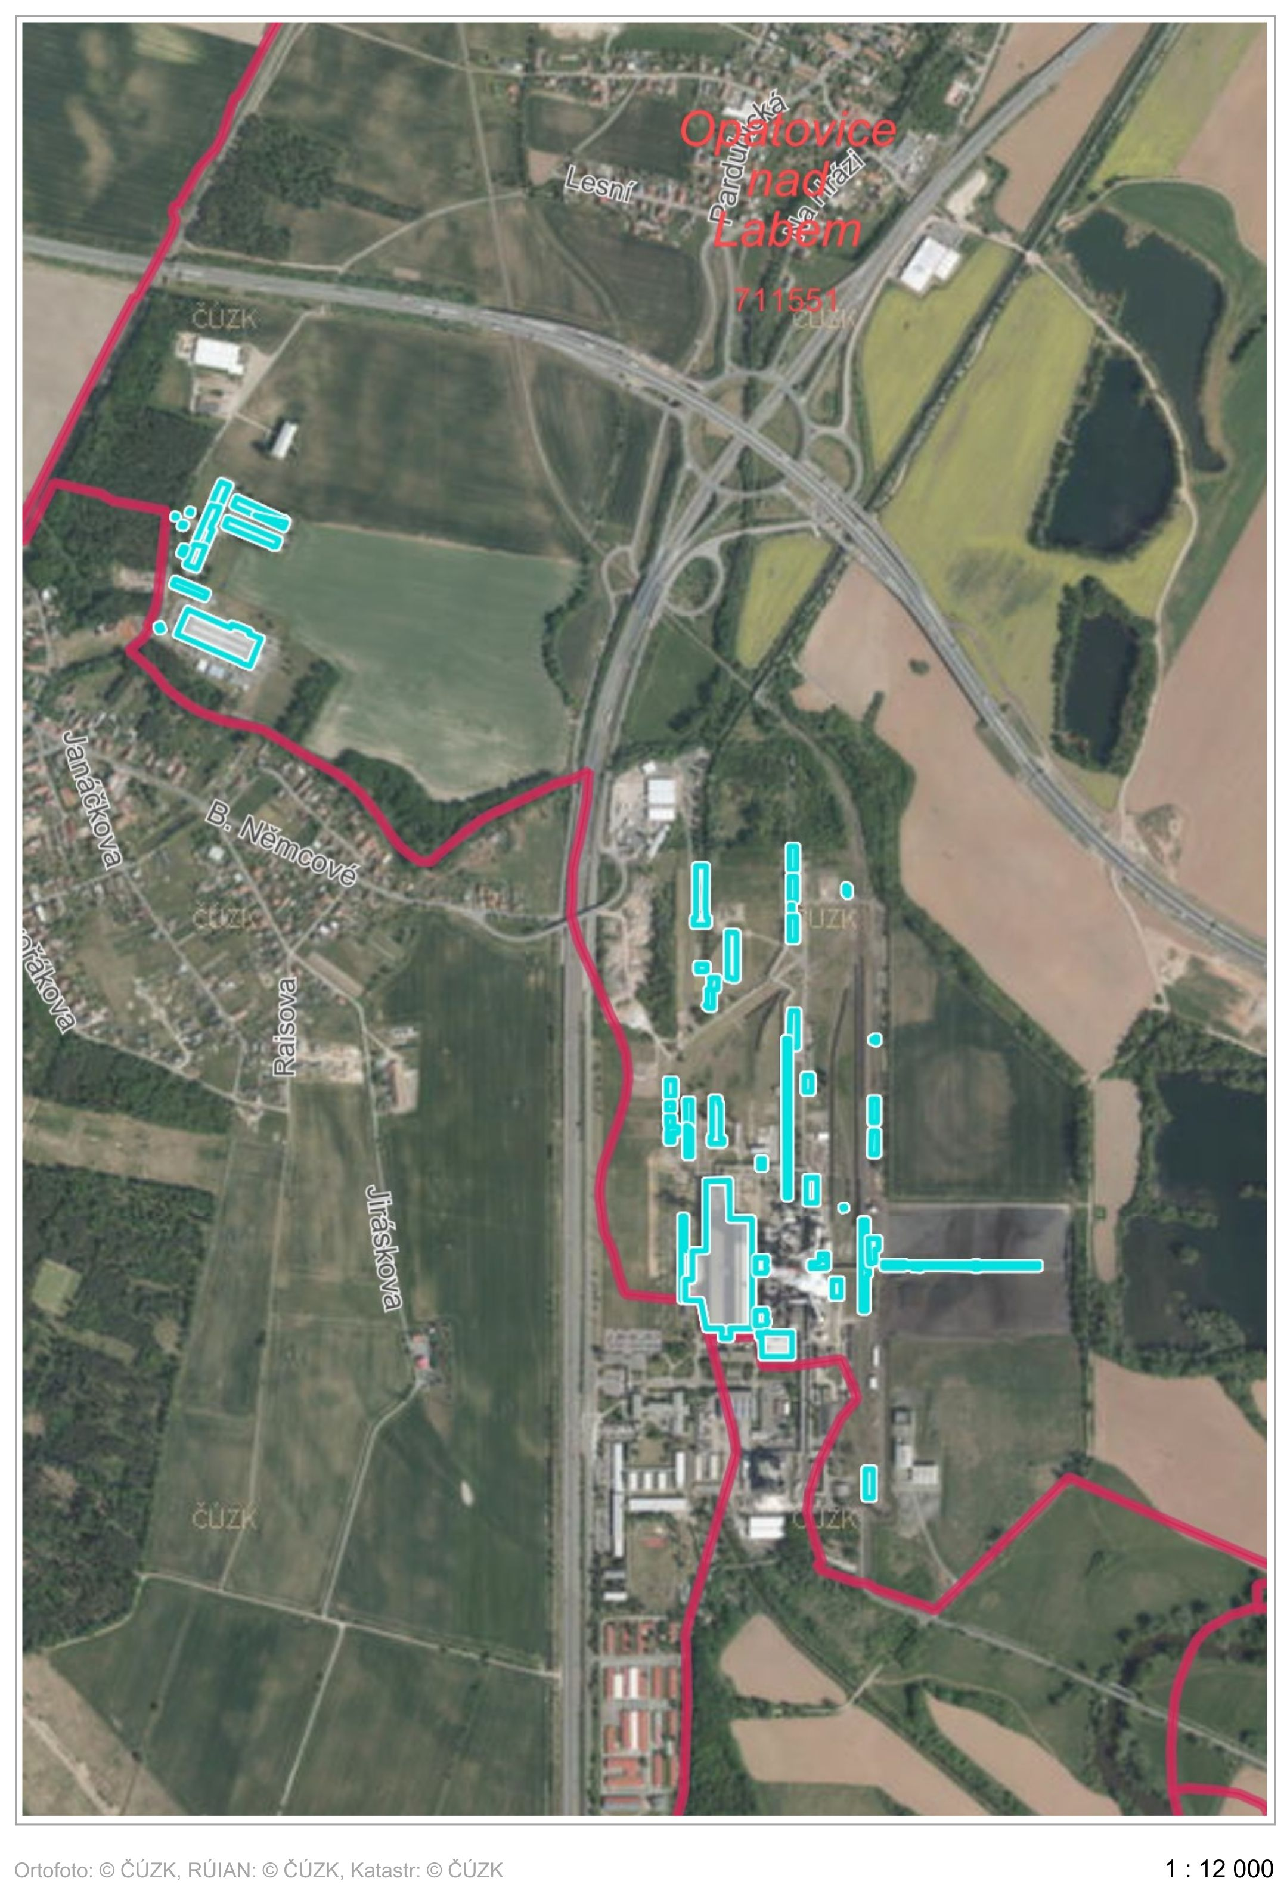
st.511, st.512, st.513, st.515, st.516, st.520, st.533, st.534, st.535, st.536/1, st.536/2, st.538, st.539, st.545, st.548, st.550, st.573, st.574, st.575, st.588, st.589, st.590, st.591, st.592, st.593, st.747, st.748, st.831, st.846, st.847, st.851, st.852, st.853, st.860, st.861, st.862, st.869, st.870, st.871, st.875, st.876, st.877, st.879, st.882, st.884, st.885, st.886, st.933, 667/1, 667/2 vše v k.ú. Opatovice nad Labem

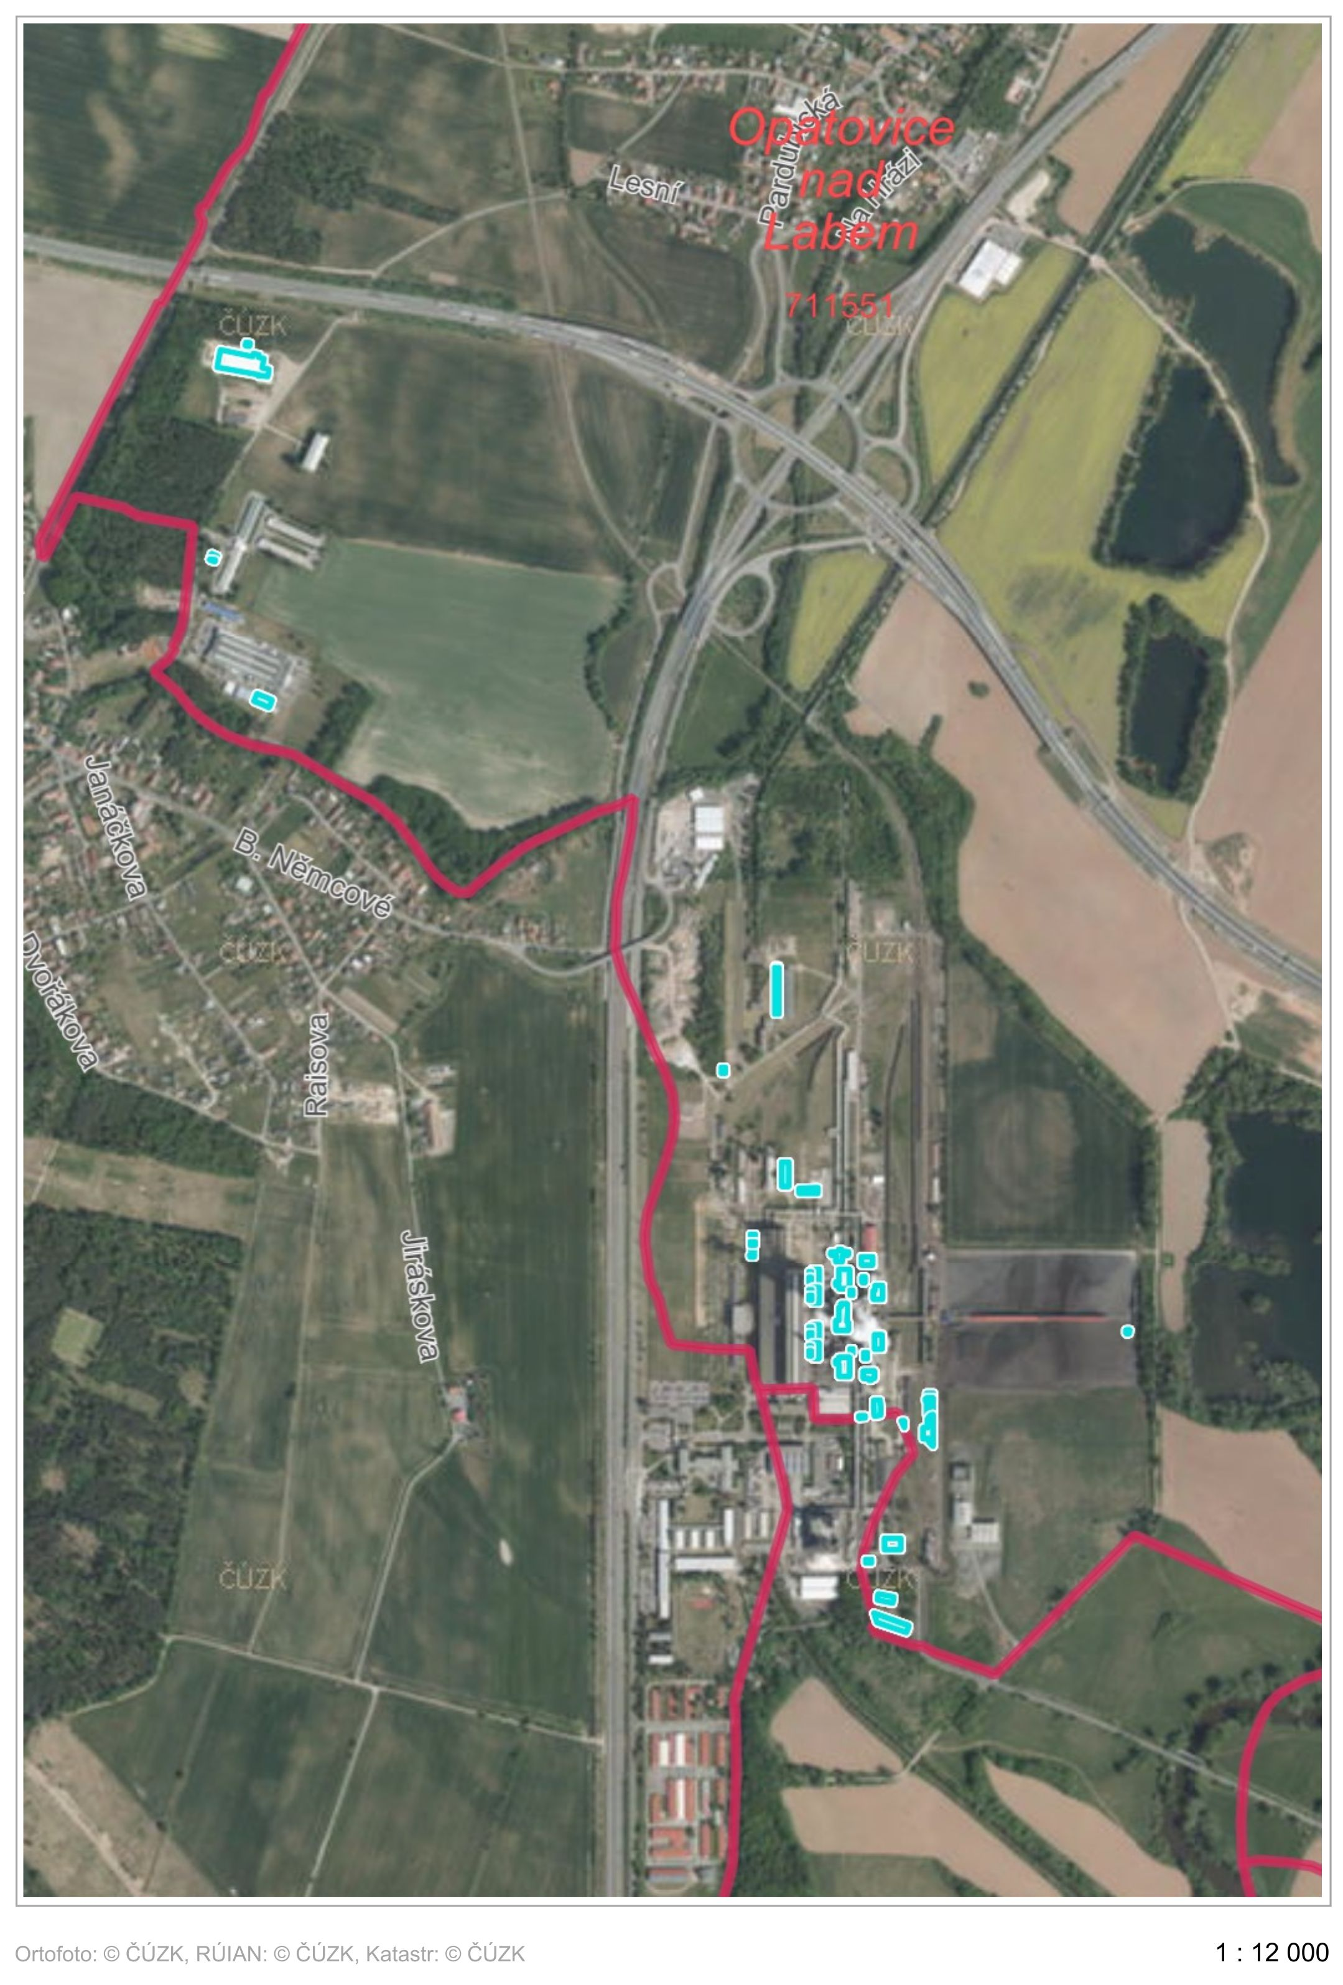
667/3, 667/4, 667/5, 667/6, 667/7, 670/2, 675/3, 724/1, 724/13, 724/19, 724/20, 724/21, 724/22, 724/33, 1476/5, 1648/1, 1648/5, 1648/16, 1648/17, 1648/18, 1648/19, 1648/20, 1648/21, 1648/29, 1648/30, 1648/31, 1648/32, 1648/34, 1648/35, 1648/36, 1648/46, 1648/52, 1648/53, 1648/54, 1649/1, 1649/3, 1650/1, 1650/3, 1650/5, 1650/6, 1653/1, 1653/3, 1650/5, 1650/6, 1653/1, 1653/3, 1653/5, 1653/6, 1673/13, 1673/20 vše v k.ú. Opatovice nad Labem
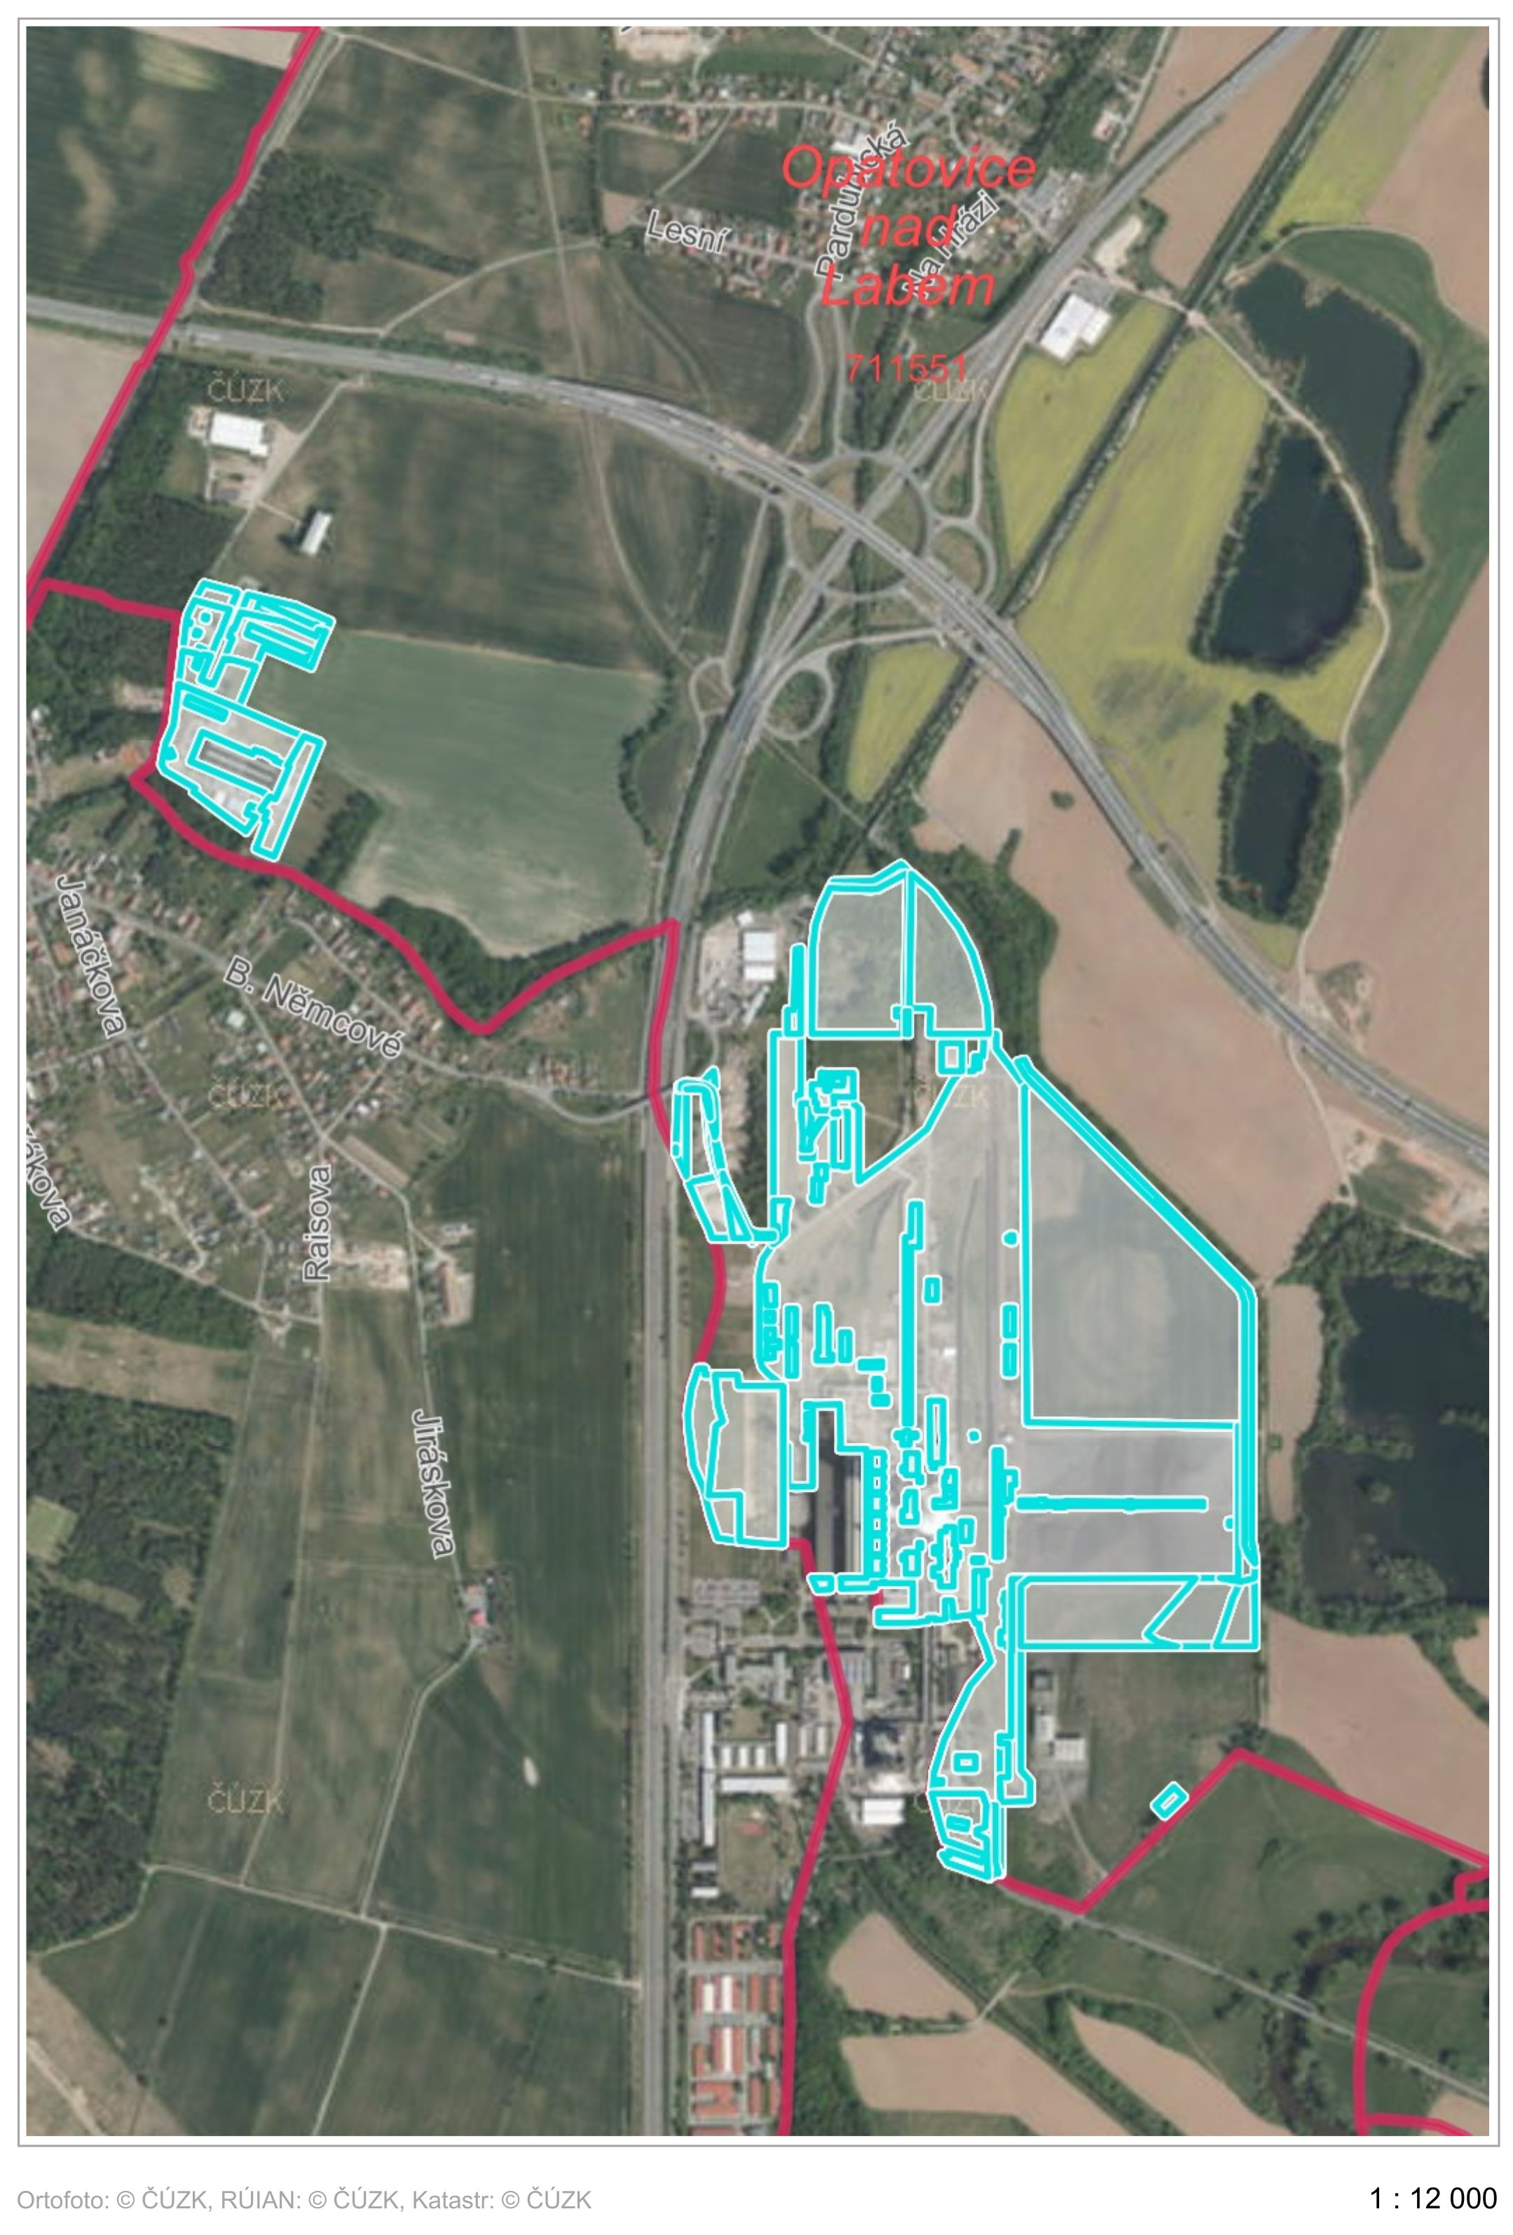
1675/1, 1675/2, 1675/3, 1675/4, 1738/1, 1738/6, 1739/2, 1739/3, 1740/1, 1740/2, 2163, 2164, 2165, 2179, 2180, 2181, 2182, 2183, 2187, 2201, 2202, 2233, 2265, 2615, 2616, 2617, 2620, 2623, 2624, 2628, 2629, 2630, 2631, 2635, 2667, 2669/1, 2672, 2673, 2675, 2687, 2713/1, 2713/2, 2713/3, 2714, 2718/1, 2718/2, 2718/3, 2719/1, 2719/2 vše v k.ú. Opatovice nad Labem

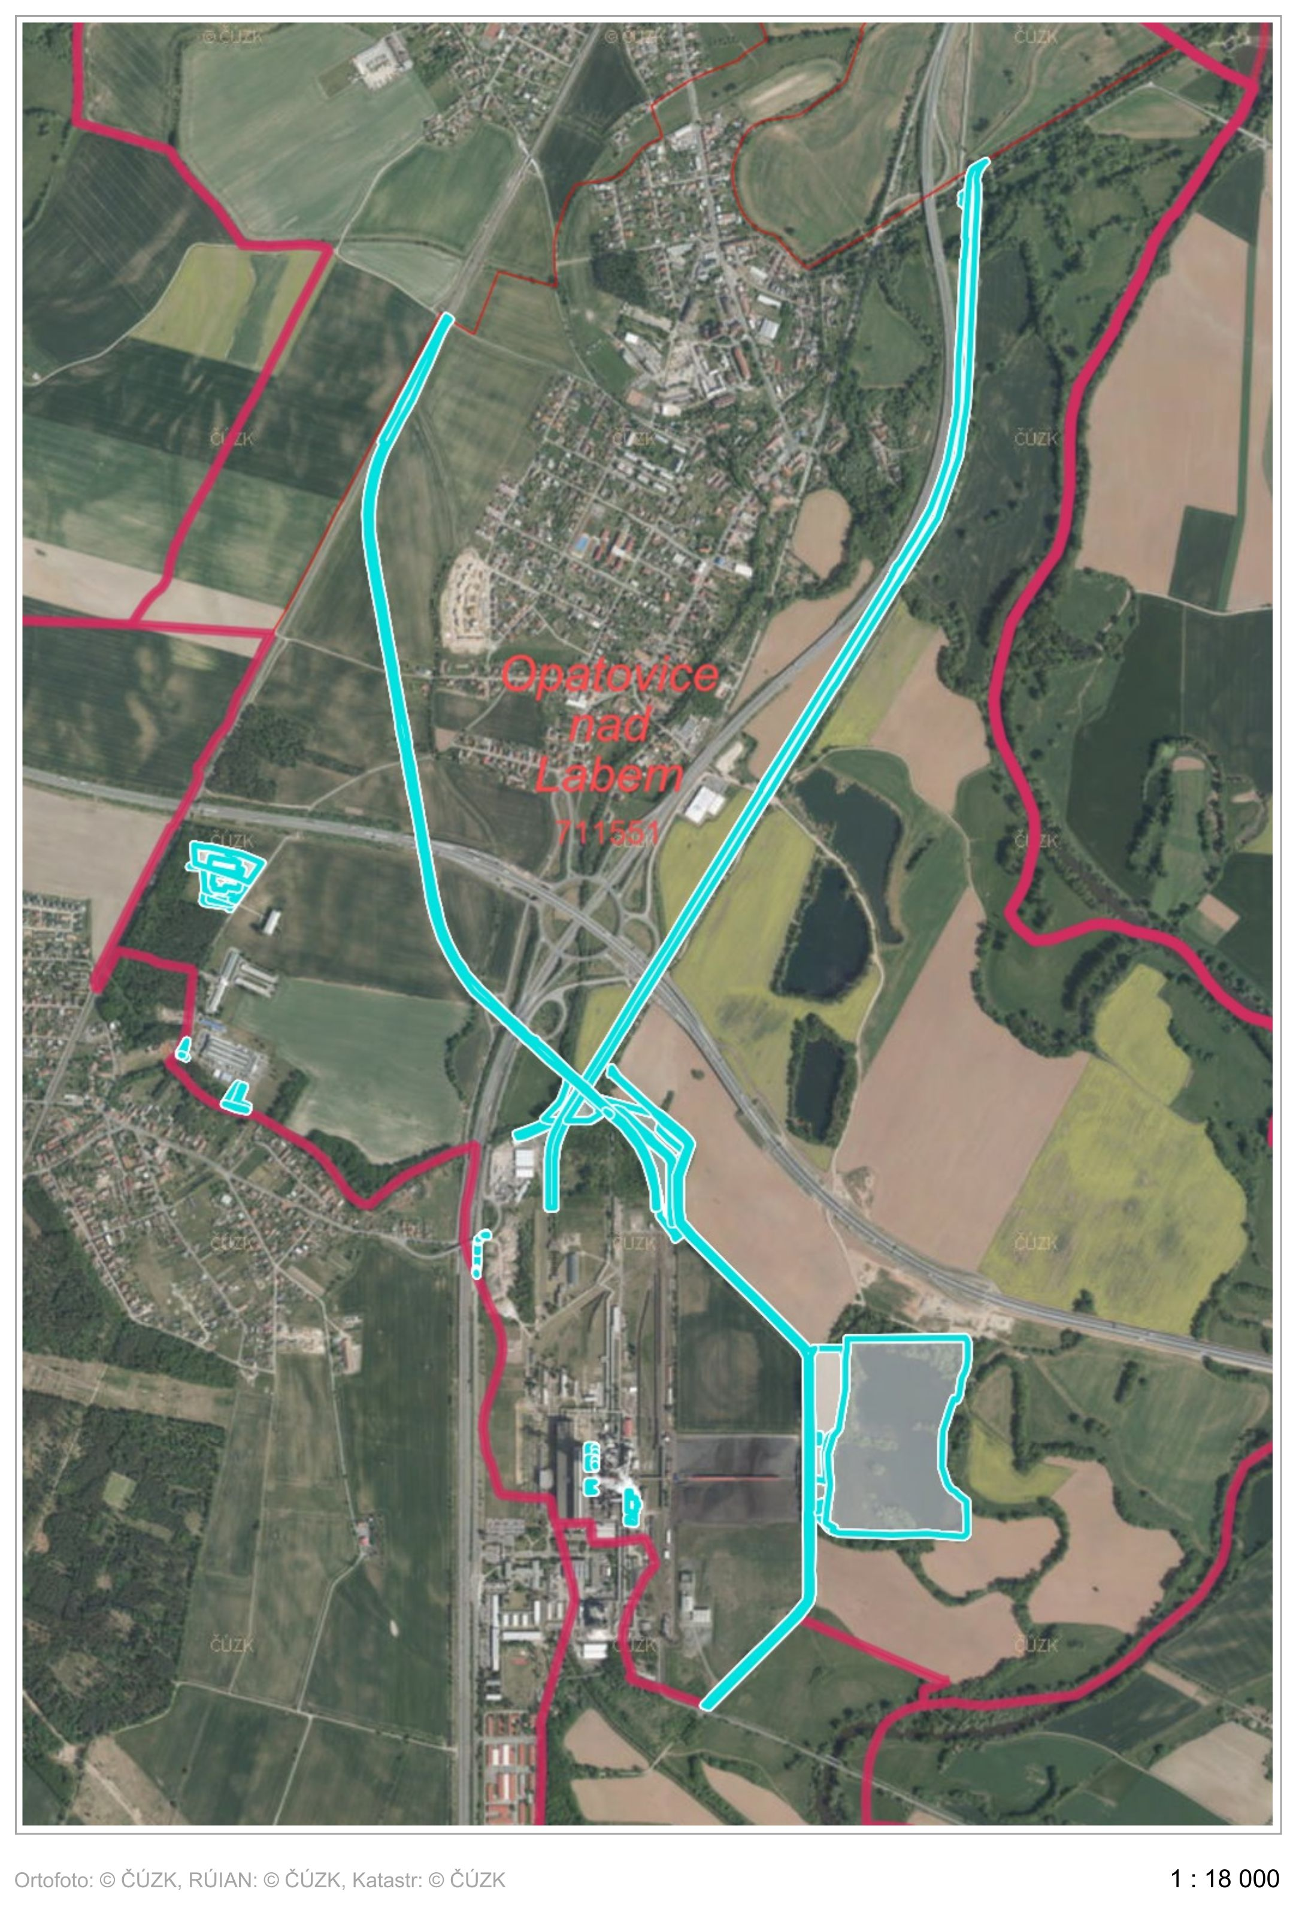
2719/3, 2720/1, 2720/2, 2720/3, 2721, 2724, 2725, 2731 vše v k.ú. Opatovice nad Labem

