|  |  |  |
| --- | --- | --- |
| Označení | Název | Souřanice |
| PZ01 | Požární nádrž Robčice | 49°39´59.067“N, 13°22´14.694“E |
| PZ02 | Rybník Robčice | 49°40´10.966“N, 13°22´11.778“E |
| NH00 | Hydrant Robčice | 49°40´12.804“N, 13°22´11.875“E |
| PZ03 | Požární nádrž Útušice | 49°40´39.248“N, 13°22´53.202“E |
| NH01 | Hydrant Útušice | 49°40´19.418“N, 13°22´46.187“E |
| NH02 | Hydrant Útušice | 49°40´23.599“N, 13°22´54.646“E |
| NH03 | Hydrant Útušice | 49°40´27.282“N, 13°23´3.042“E |
| NH04 | Hydrant Útušice | 49°40´30.672“N, 13°23´12.442“E |
| NH05 | Hydrant Útušice | 49°40´33.769“N, 13°23´15.556“E |
| NH06 | Hydrant Útušice | 49°40´36.487“N, 13°23´18.597“E |
| NH07 | Hydrant Útušice | 49°40´36.105“N, 13°23´4.582“E |
| NH08 | Hydrant Útušice | 49°40´33.512“N, 13°23´3.940“E |
| NH09 | Hydrant Útušice | 49°40´41.241“N, 13°22´54.110“E |
| NH10 | Hydrant Útušice | 49°40´50.670“N, 13°23´4.567“E |
| NH11 | Hydrant Útušice | 49°40´40.770“N, 13°22´59.010“E |
| NH12 | Hydrant Útušice | 49°40´40.423“N, 13°23´11.017“E |
| NH13 | Hydrant Útušice | 49°40´45.746“N, 13°22´51.387“E |
| NH14 | Hydrant Útušice | 49°40´46.037“N, 13°23´1.323“E |
| NH15 | Hydrant Útušice | 49°40´46.771“N, 13°22´45.555“E |
| NH16 | Hydrant Útušice | 49°40´33.084“N, 13°22´56.635“E |
| NH17 | Hydrant Útušice | 49°40´37.796“N, 13°22´53.897“E |
| NH18 | Hydrant Útušice | 49°40´30.488“N, 13°22´51.817“E |
| NH19 | Hydrant Útušice | 49°40´42.310“N, 13°22´41.924“E |

Útušice

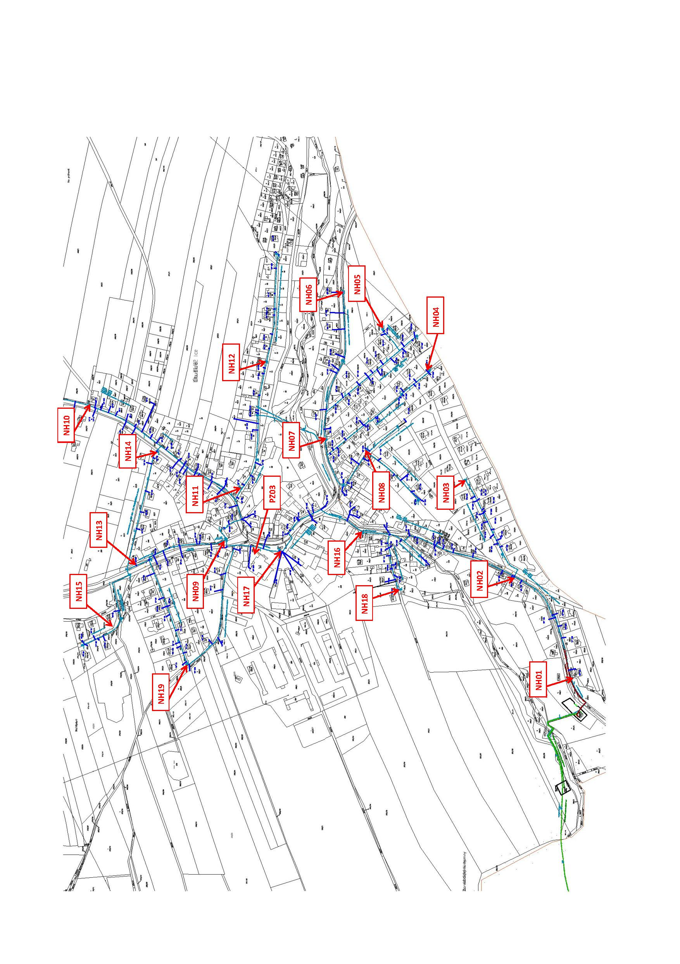

Robčice

